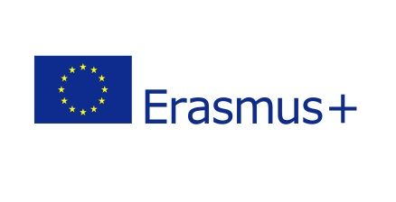

NATIONAL TECHNICAL UNIVERSITY OF UKRAINE
“IGOR SIKORSKY KYIV POLYTECHNIC INSTITUTE”

CERTIFICATE OF ATTENDANCE
STAFF MOBILITY FOR TRAINING

“Erasmus+” KA1 (ICM) Academic year 2019/2020

We hereby confirm that Mr NAME SURNAME
from UNIVERSITY NAME
has taught 8 hours of lectures as Staff for Teaching within ERASMUS+ Programme at National Technical University of Ukraine “Igor Sikorsky Kyiv Polytechnic Institute”

FROM 19.03.2018 TO 23.03.2018

At Faculty of Management and Marketing

23.03.2018 Dean of Faculty of Management and Marketing
Kyiv, Ukraine Oleh Havrysh

National Technical University of Ukraine “Igor Sikorsky Kyiv Polytechnic Institute”
37, Peremohy Avenue, 03056 Kyiv Ukraine
+38 (044) 2049955 mobilnist@kpi.ua mobilnist.kpi.ua/en

